EXPT NO: 7 | GENERATE SYNTHETIC IMAGES USING A GENERATIVE ADVERSARIAL NETWORK (GAN)
DATE: 08.10.26

PRE-LAB QUESTIONS (PROVIDE BRIEF ANSWERS TO THE FOLLOWING QUESTIONS)

- What is a Generative Adversarial Network (GAN)?
A Generative Adversarial Network (GAN) is a deep learning model used to generate new, realistic data such as images. It consists of two neural networks called the Generator and Discriminator that compete with each other during training.

- What are the roles of the Generator and Discriminator in a GAN?
• Generator: Creates synthetic images from random noise.
• Discriminator: Determines whether an image is real from the dataset or fake generated by the Generator.

- Why are GANs used for synthetic image generation?
GANs can learn the patterns and features of real images and use this knowledge to create new and realistic synthetic images. They are useful for data augmentation, image creation, and other computer vision applications.

- What is the difference between real images and synthetic images?
• Real images: Original images collected from a dataset or real-world source.
• Synthetic images: New images generated artificially by a model such as a GAN

- Explain the concept of adversarial training in GANs.
Adversarial training means the Generator and Discriminator compete with each other. The Generator tries to create images that look real, while the Discriminator tries to identify fake images. Through this competition, the Generator gradually improves the quality of its images.

AIM
To implement a Generative Adversarial Network (GAN) for generating synthetic images by training a Generator and Discriminator on an image dataset and evaluating the quality of the generated images.

SOFTWARE REQUIREMENTS
- Python
- TensorFlow / Keras
- Google Colab
- GitHub
- NumPy
- Matplotlib
- Pandas

OBJECTIVES
Students will be able to:
- Understand the architecture and working of Generative Adversarial Networks.
- Understand the roles of the Generator and Discriminator.
- Prepare and preprocess an image dataset for GAN training.
- Build a Generator network for synthetic image generation.
- Build a Discriminator network for distinguishing real and generated images.
- Train a GAN using adversarial learning.
- Generate synthetic images using the trained Generator.
- Visualize and analyze the quality of generated images.

PROCEDURE
PART A: DATASET PREPARATION AND IMAGE PREPROCESSING
Perform the following tasks:
- Load an image dataset such as the MNIST handwritten digit dataset.
- Explore the dataset and examine sample images.
- Check the number of images and image dimensions.
- Display sample images from the dataset.
- Normalize the pixel values to the range [-1, 1].
- Reshape the images into the required input format.
- Prepare the dataset for batch-wise training.
- Create a data pipeline using appropriate TensorFlow/Keras utilities.
(CODE: CONATAINS STUDENT ROLL NOS
SCREENSHOT OF CODE
SCREENSHOT OF OUTPUT)

PART B: IMPLEMENTING THE GENERATOR
Perform the following tasks:
- Define a random noise vector as the input to the Generator.
- Create the Generator using appropriate neural network layers.
- Use Dense and convolutional/transposed convolutional layers to generate images.
- Apply appropriate activation functions.
- Generate an image from a random noise vector.
- Display the generated image before GAN training.
- Display the Generator model architecture and summary.
(CODE: CONATAINS STUDENT ROLL NOS
SCREENSHOT OF CODE
SCREENSHOT OF OUTPUT)

PART C: IMPLEMENTING THE DISCRIMINATOR AND GAN MODEL
Perform the following tasks:
- Create a Discriminator network to classify images as real or generated.
- Add convolutional layers to extract image features.
- Add appropriate activation functions.
- Add a final output layer for binary classification.
- Compile the Discriminator using:
  - Appropriate optimizer
  - Binary cross-entropy loss
- Combine the Generator and Discriminator to form the GAN.
- Display the Generator and Discriminator model summaries.
(CODE: CONATAINS STUDENT ROLL NOS
SCREENSHOT OF CODE
SCREENSHOT OF OUTPUT)

PART D: GAN TRAINING AND SYNTHETIC IMAGE GENERATION
Perform the following tasks:
- Initialize the Generator with random noise.
- Train the Discriminator using:
  - Real images from the dataset.
  - Synthetic images generated by the Generator.
- Train the Generator through the combined GAN model.
- Record:
  - Generator loss
  - Discriminator loss
- Repeat the training process for the specified number of epochs.
- Generate synthetic images at regular training intervals.
- Visualize generated images at different stages of training.
- Compare the generated images with real images.
- Analyze the quality and diversity of the generated images.
- Save the final generated images.
CODE:

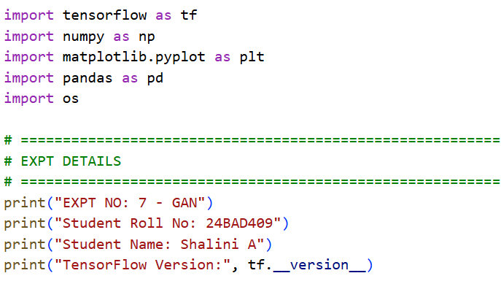
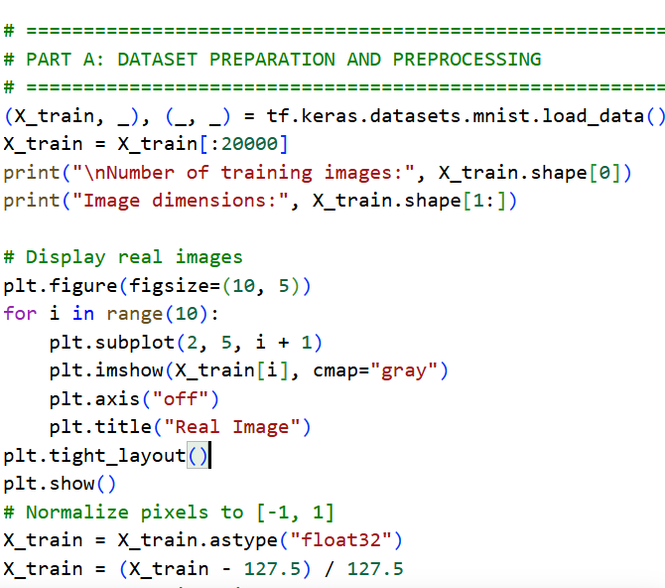
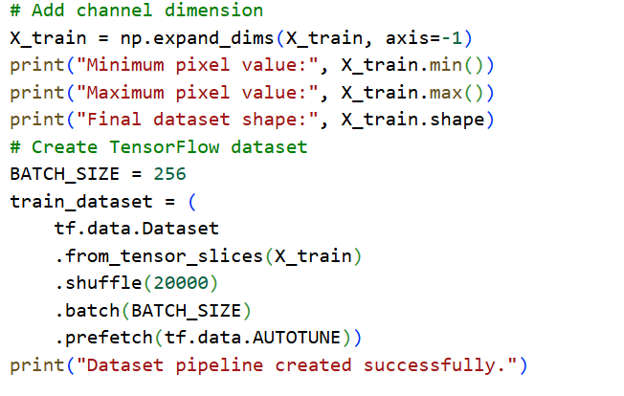
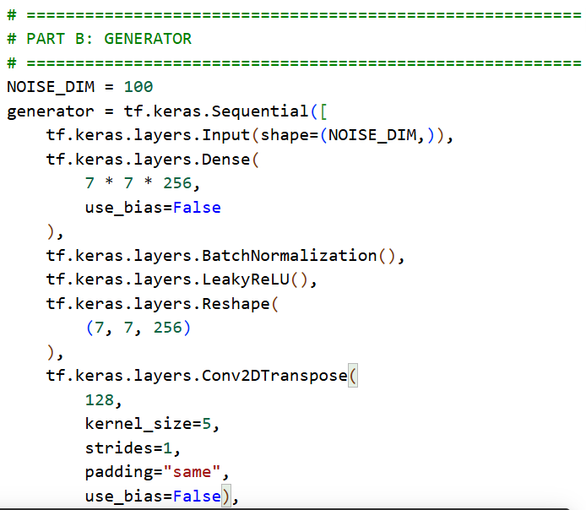
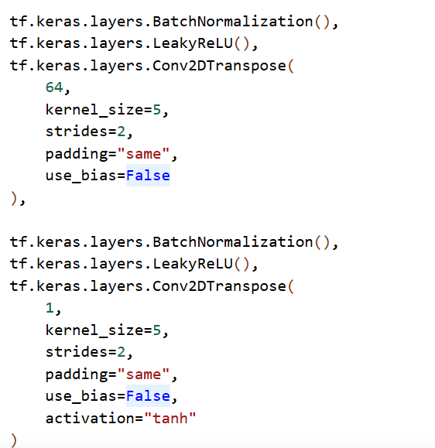
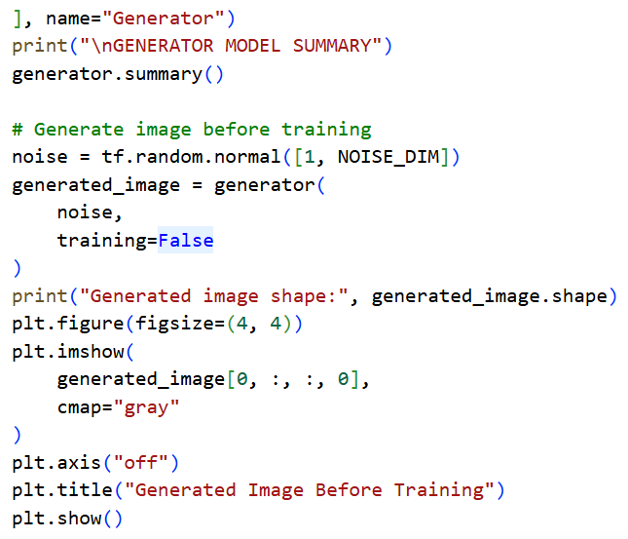

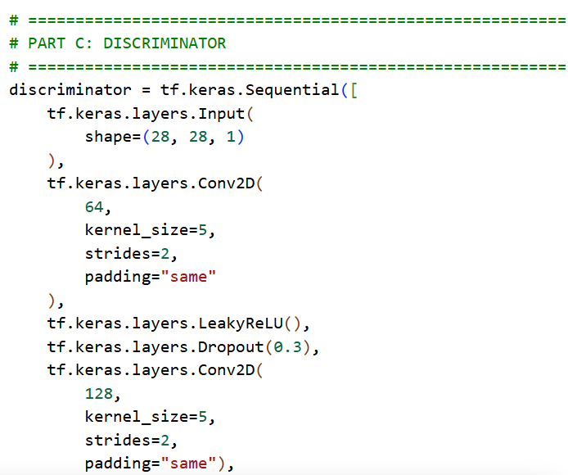
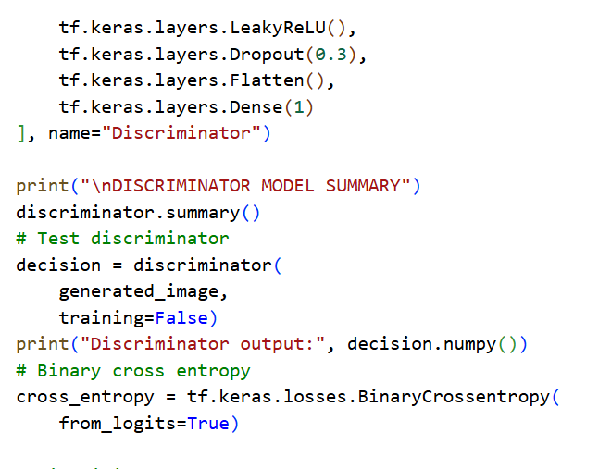
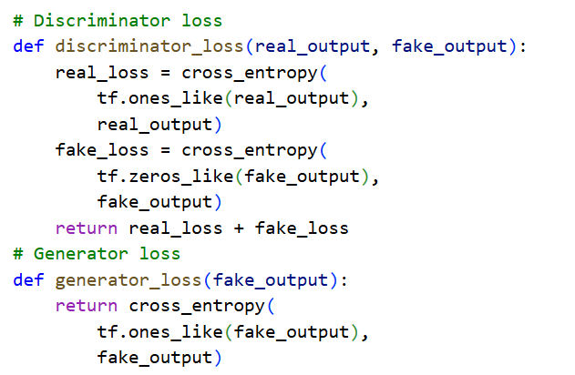

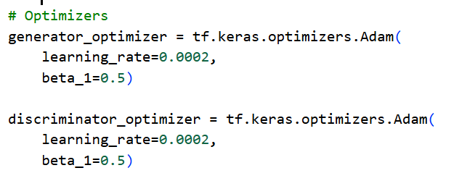
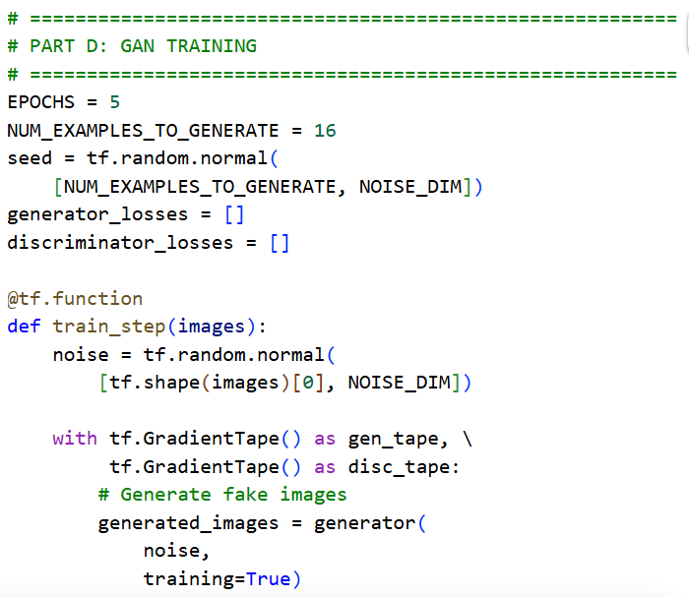
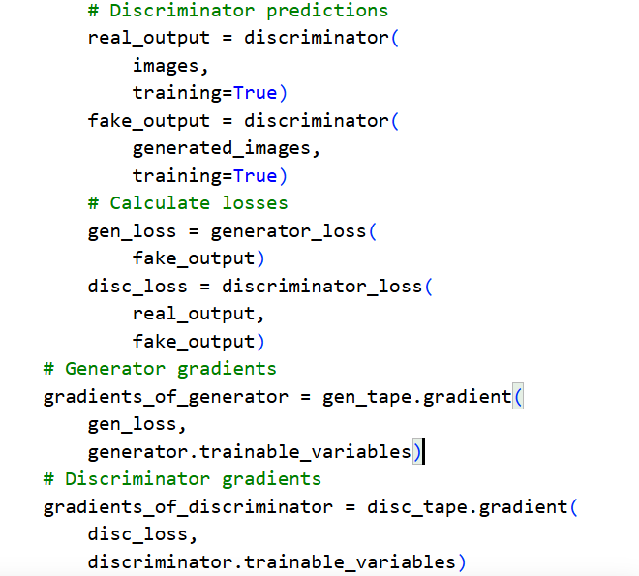
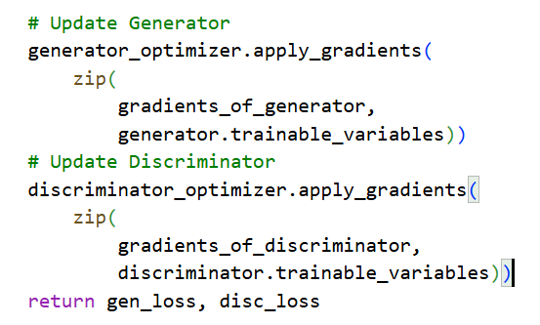

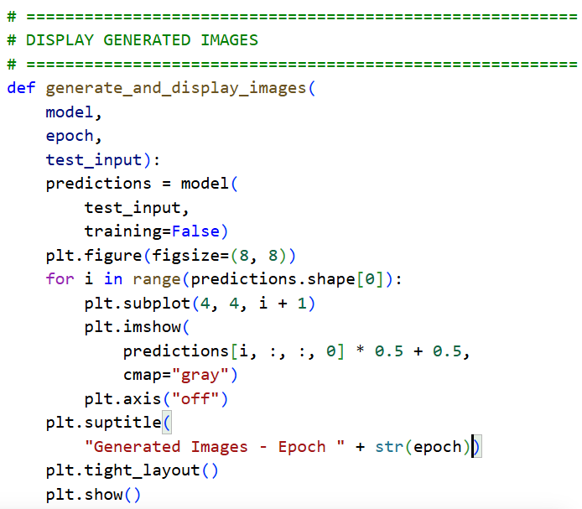
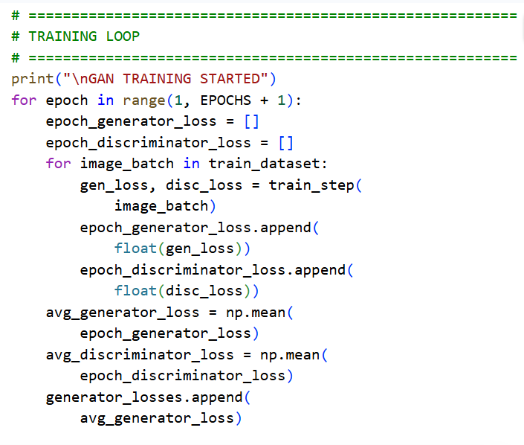
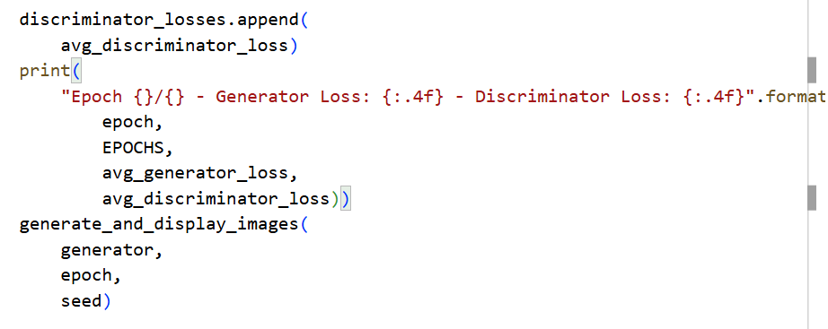
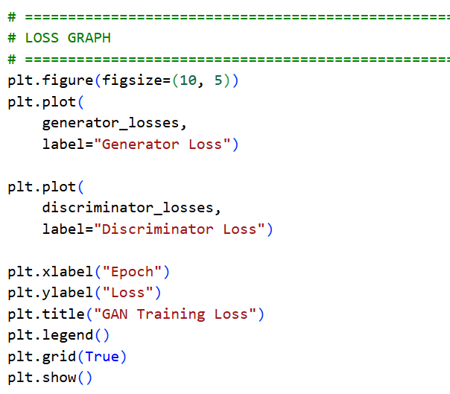
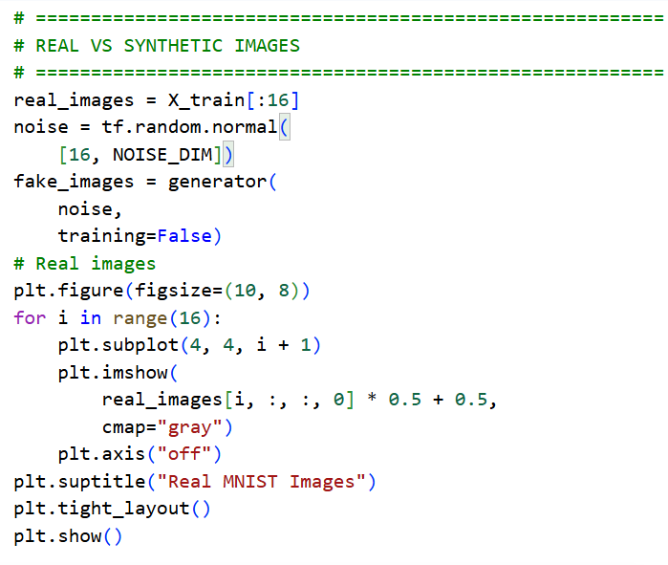
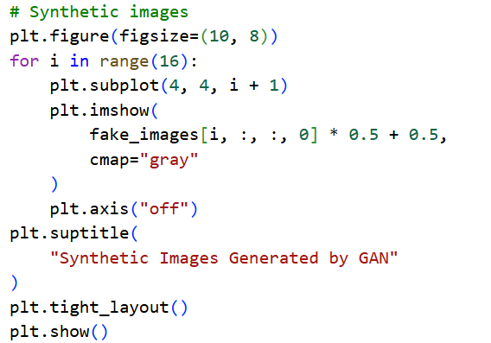
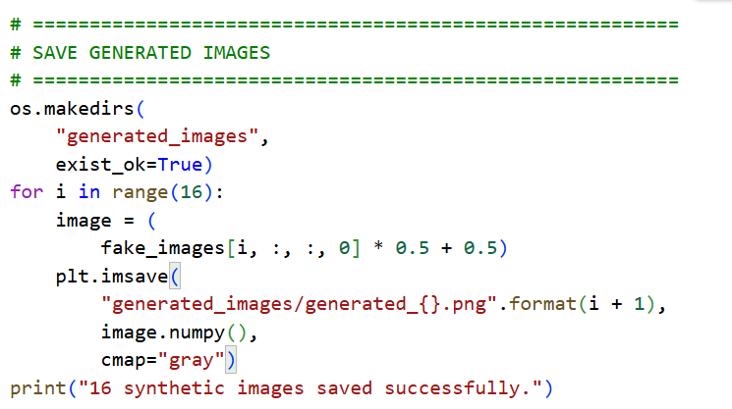
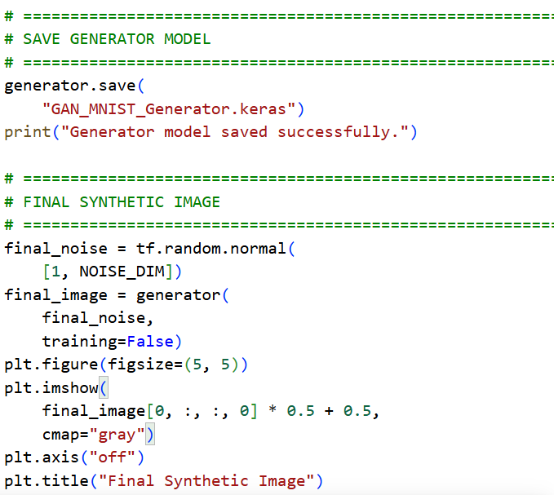
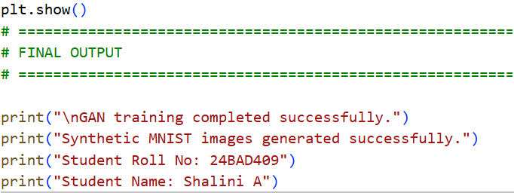

Output:
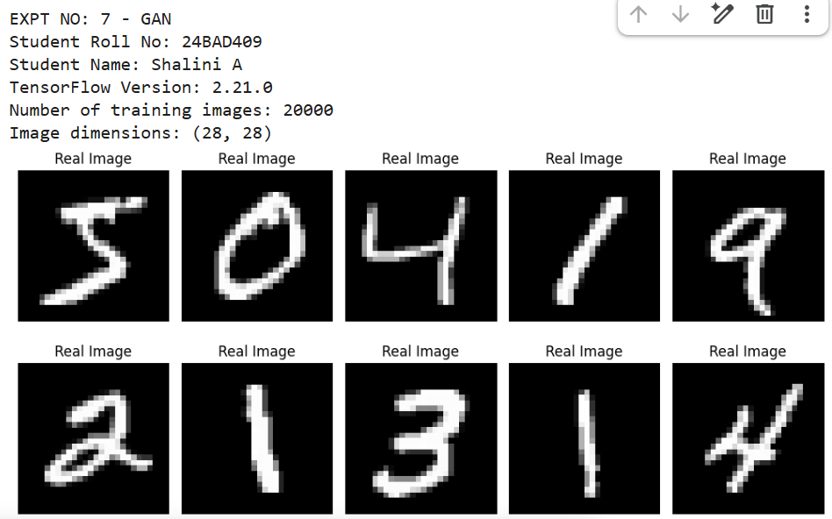
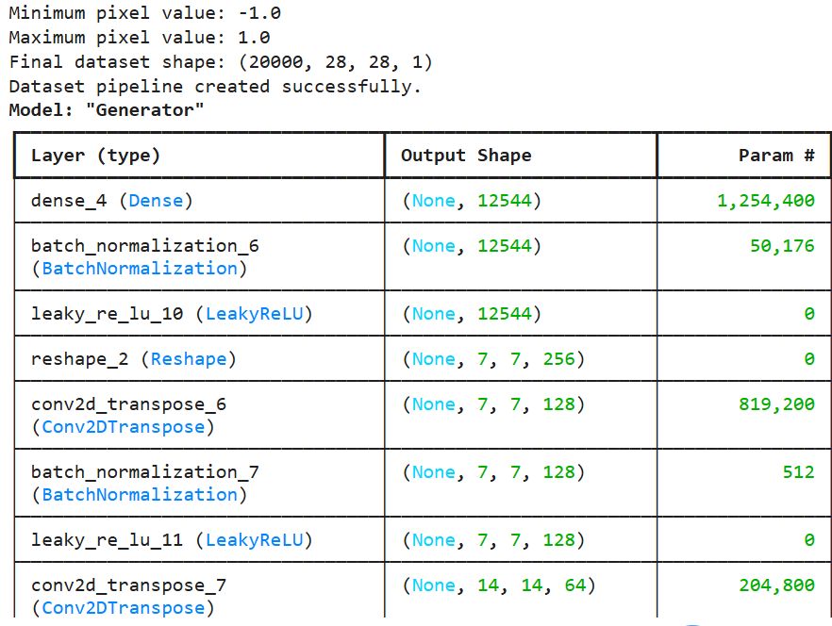
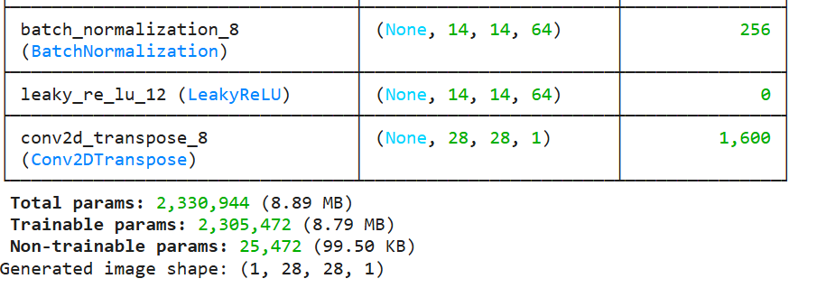
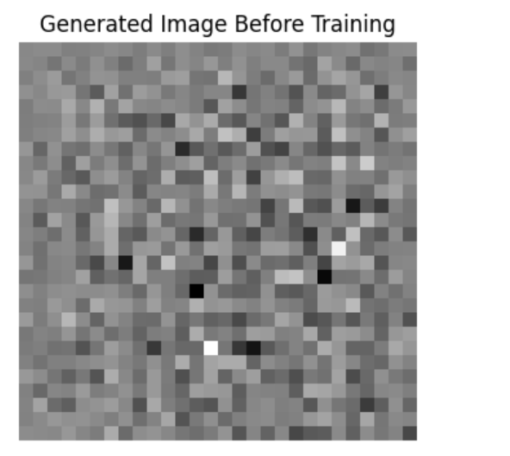
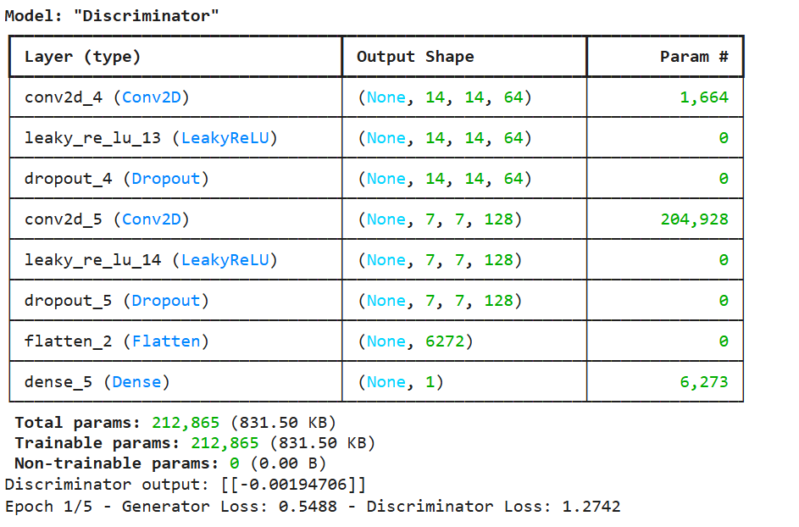
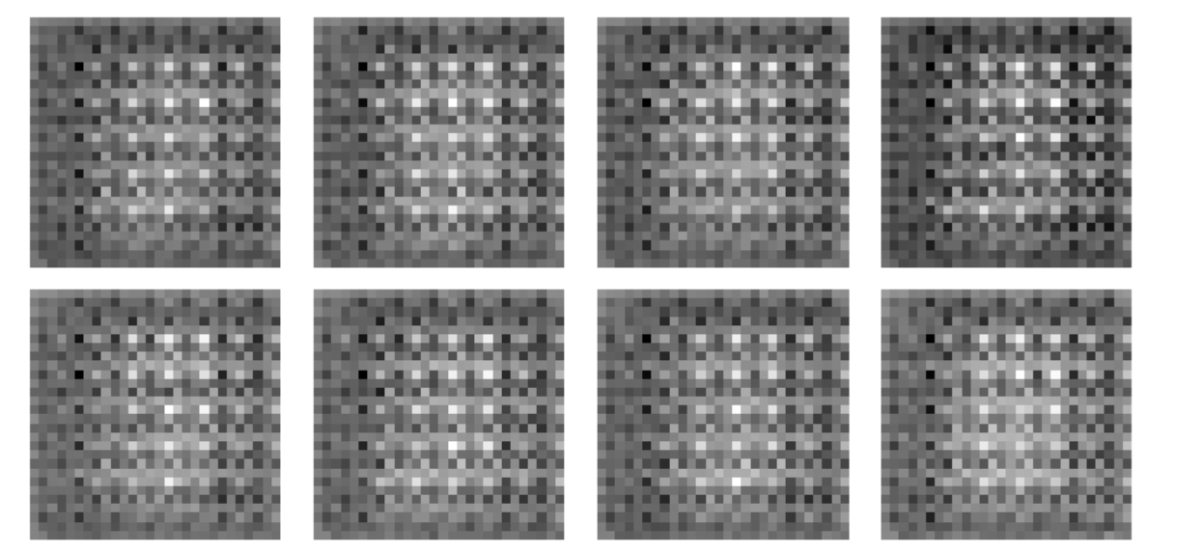
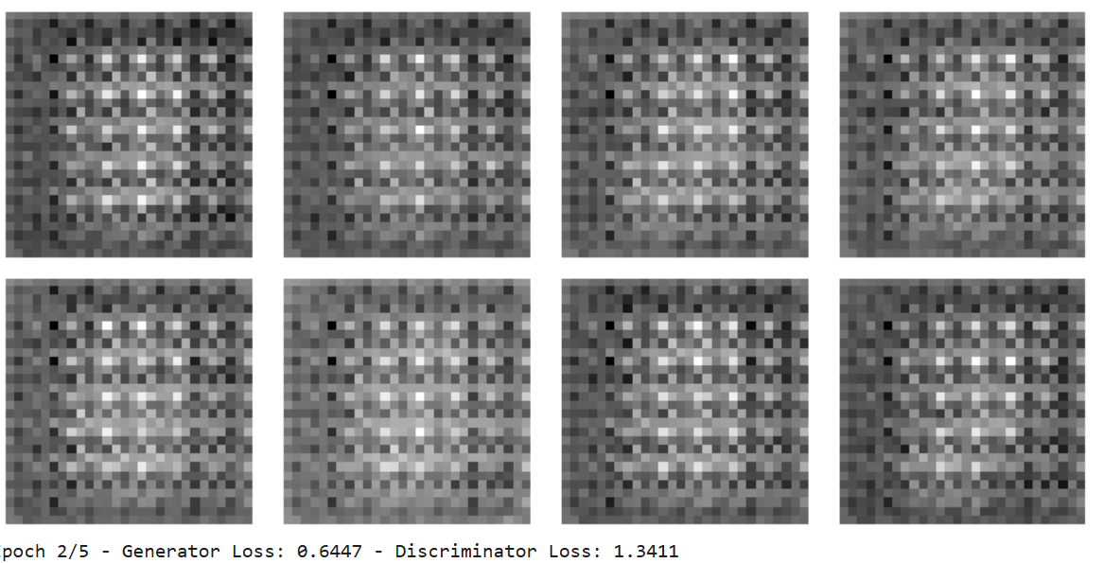
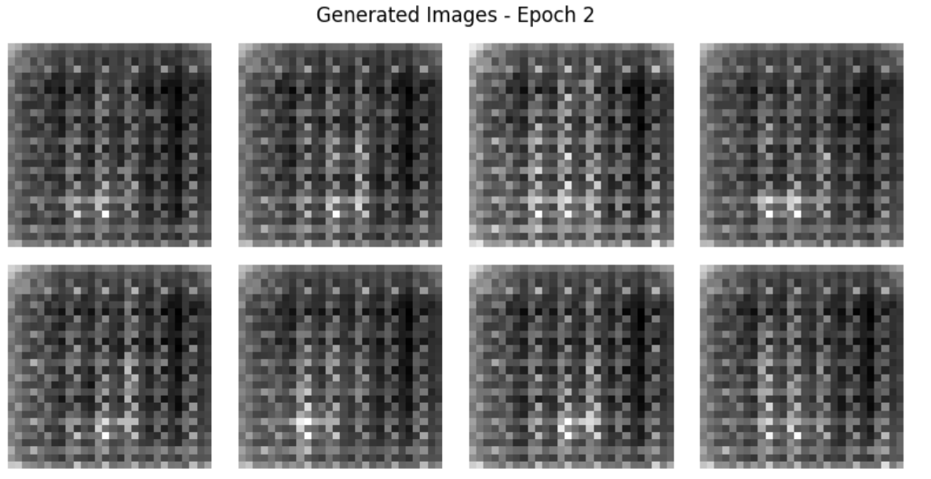
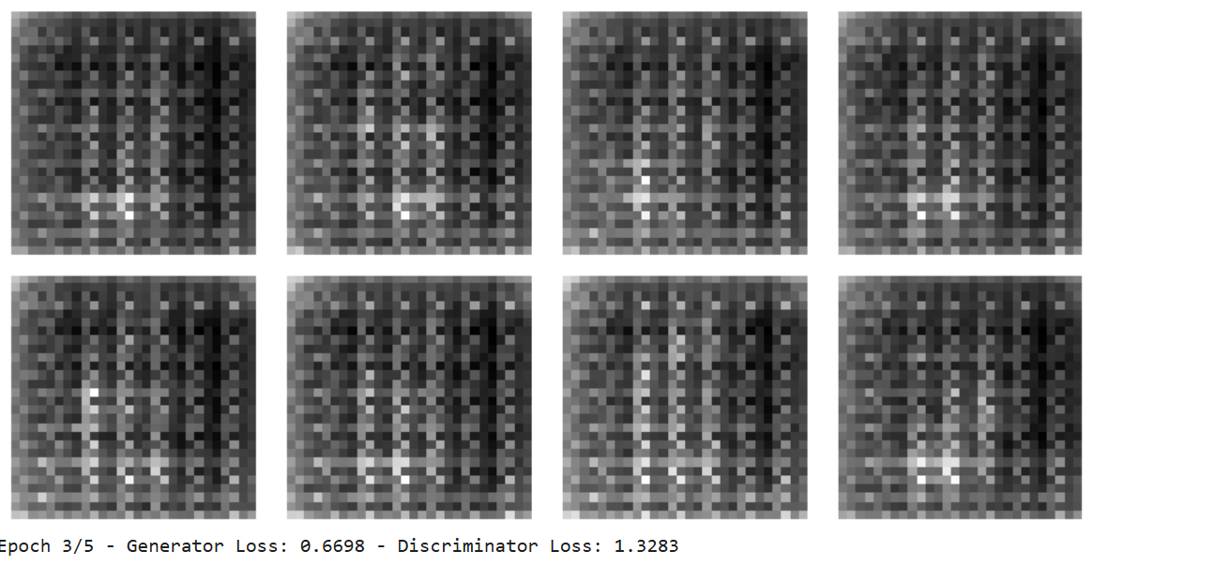
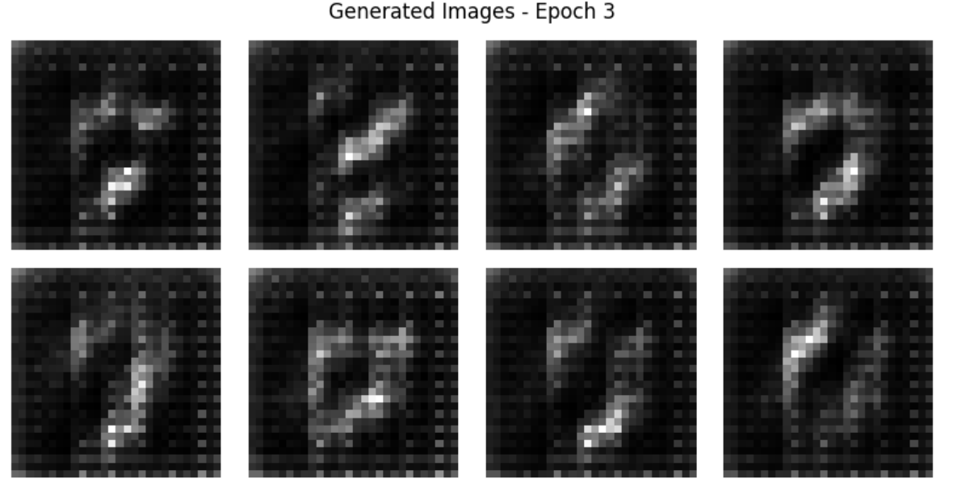
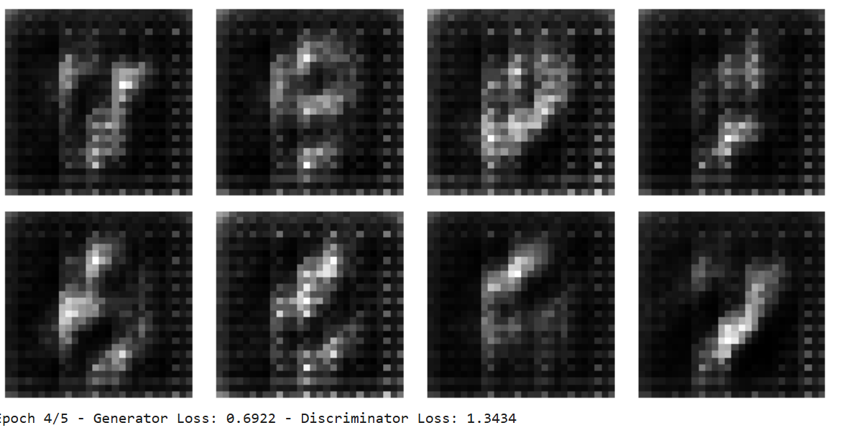

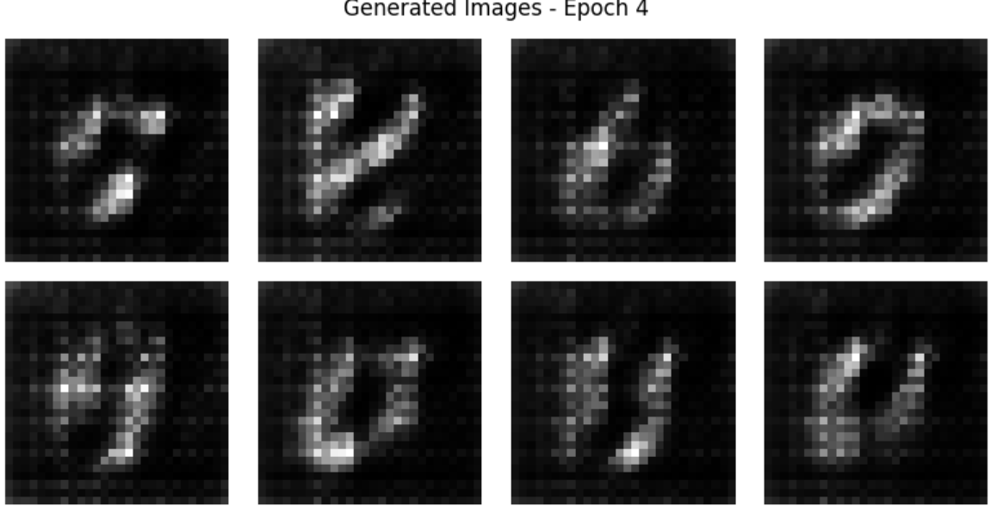
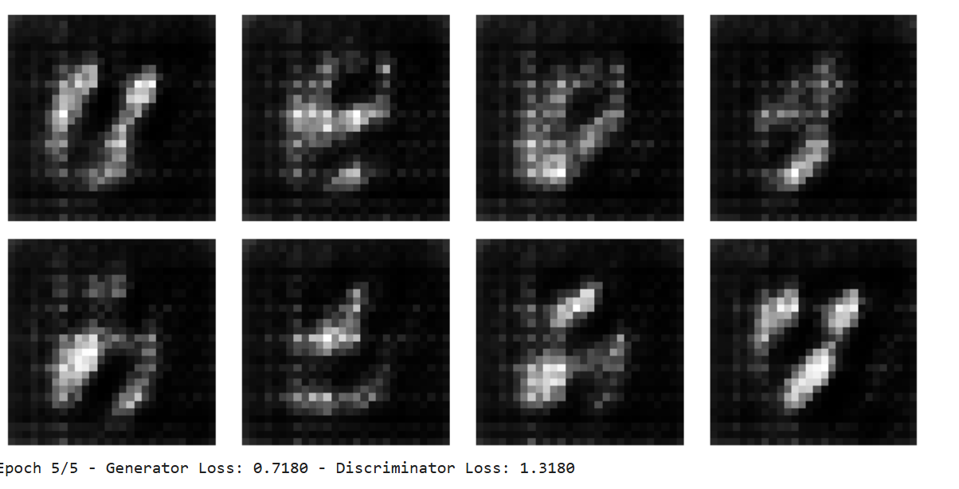
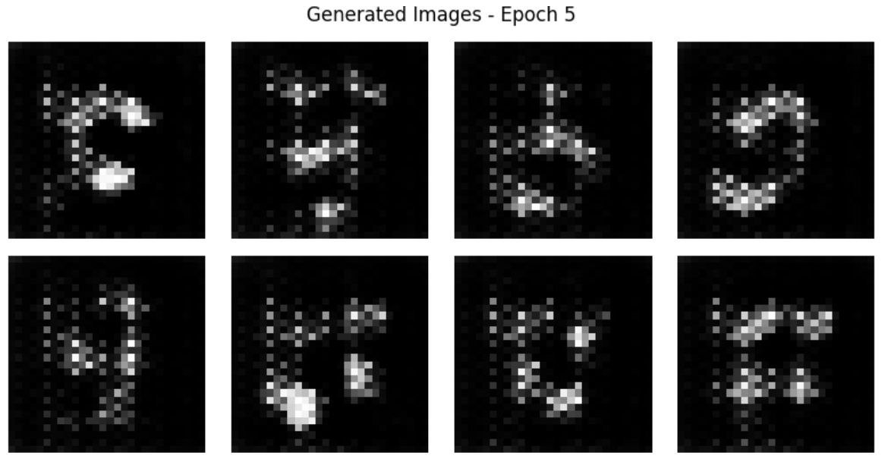
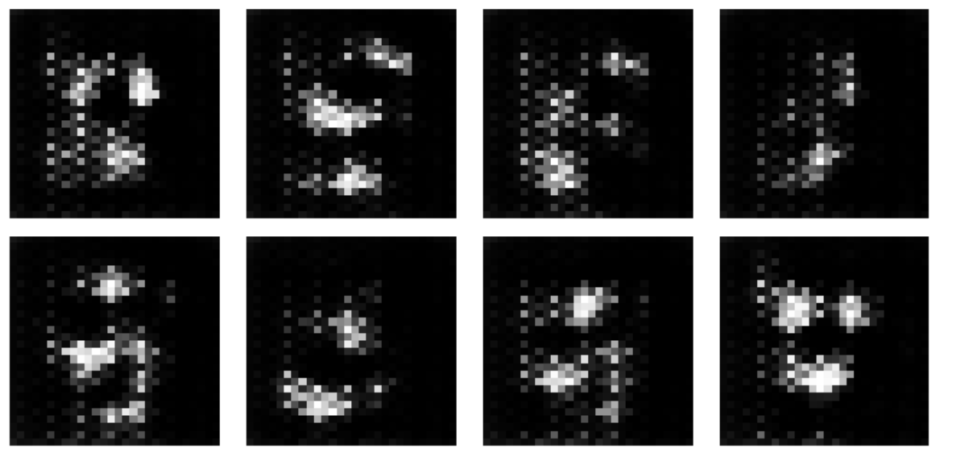

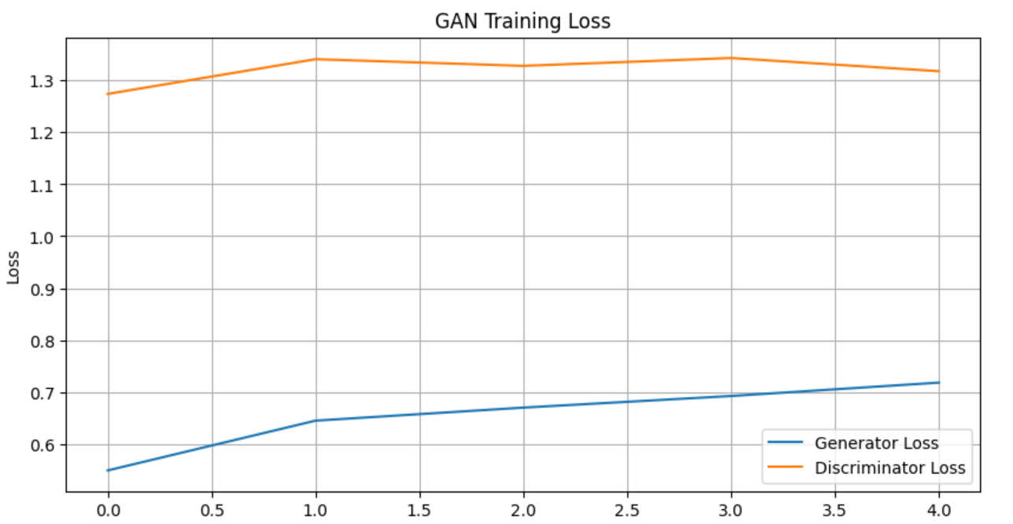
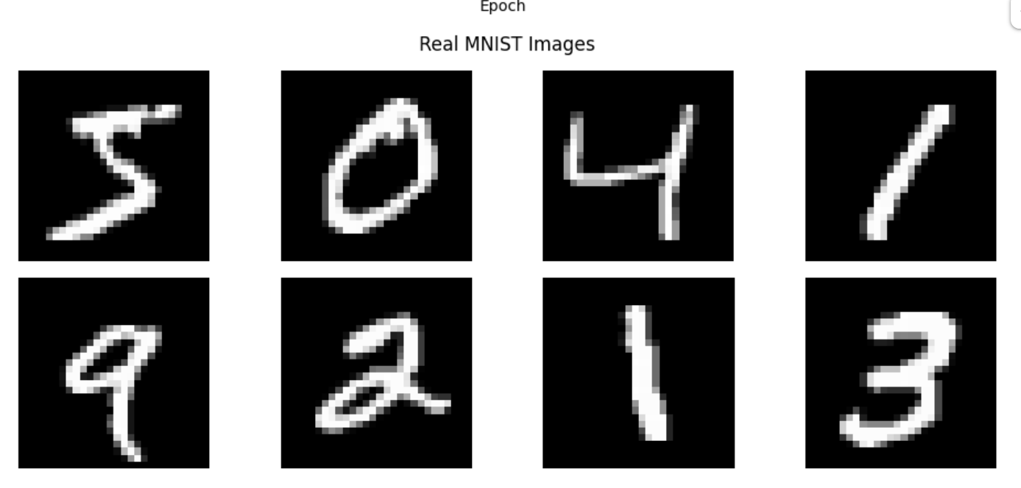
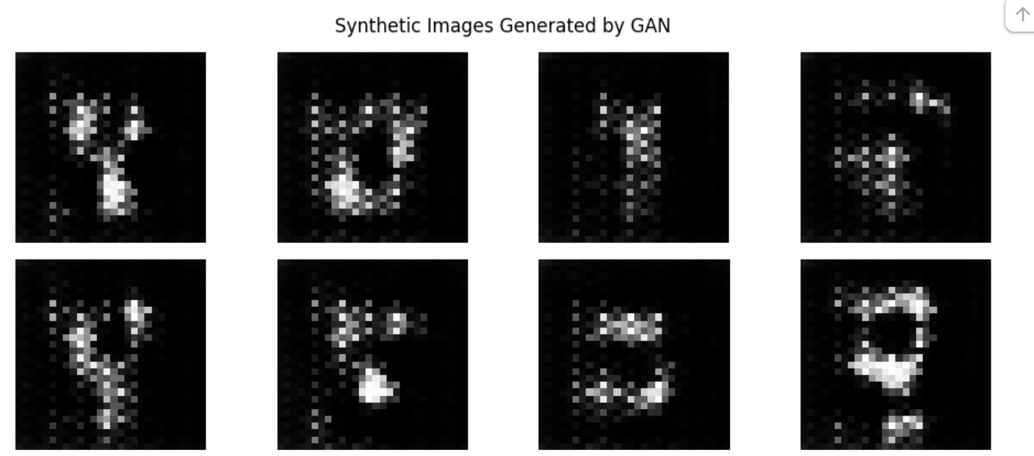
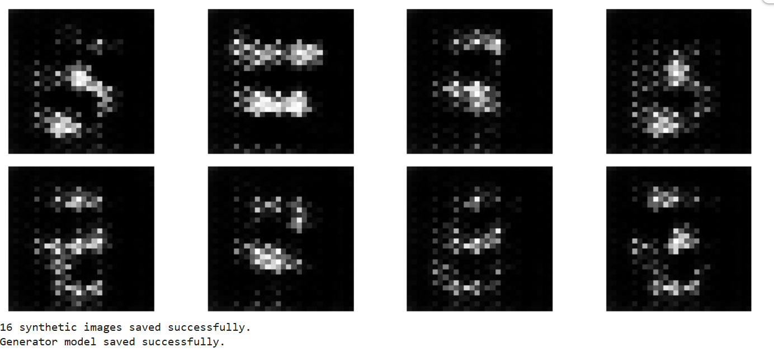
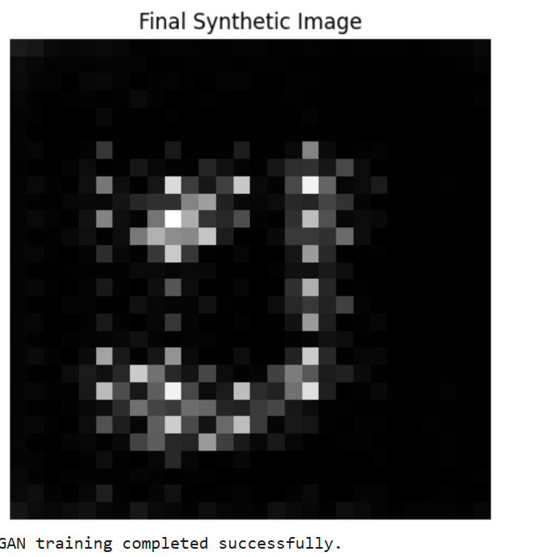
EXPECTED OUTCOME
Students will understand the architecture and working of Generative Adversarial Networks (GANs) and the interaction between the Generator and Discriminator during adversarial training. Students will learn to preprocess image data, build and train GAN models, and generate synthetic images. They will evaluate the generated images by visually comparing them with real images and analyzing the improvement in image quality during training.

POST-LAB QUESTIONS (PROVIDE BRIEF ANSWERS TO THE FOLLOWING QUESTIONS)

- What is the role of the Generator in a GAN?
The Generator creates synthetic images from random noise and tries to make them look similar to real images.
It learns from the feedback of the Discriminator and gradually improves the quality and realism of the generated images.

- What is the role of the Discriminator in a GAN?
The Discriminator classifies images as real or fake and helps the Generator learn to produce more realistic images.
It takes both real images and generated images as input and gives a probability indicating whether the image is real or fake.

- Why is random noise used as input to the Generator?
Random noise provides a random starting point for the Generator and helps it create different images.
By using different noise vectors, the Generator can produce a variety of synthetic images rather than generating the same image repeatedly.

- What happens when the Discriminator becomes too strong during GAN training?
If the Discriminator becomes too strong, it can easily identify fake images produced by the Generator. As a result, the Generator receives weak learning signals and may find it difficult to improve its generated images.

- What is meant by mode collapse in GANs?
Mode collapse is a problem in GAN training where the Generator produces very similar or identical images repeatedly. This reduces the diversity of the generated images even though the images may appear realistic.

- How does the Generator improve the quality of generated images during training?
The Generator improves by learning from the feedback and loss produced by the Discriminator.
It updates its network weights during training so that its generated images become more realistic and harder for the Discriminator to identify as fake.

- Mention one real-world application of GANs.
One important application of GANs is synthetic image generation, where realistic images can be created artificially.GANs can also be used for data augmentation, image enhancement, and creating additional training data for machine learning models.

- What is the difference between GAN training and conventional neural network training?
In conventional neural network training, a model generally learns from input data and known target labels to minimize its prediction error.
In GAN training, two networks—the Generator and Discriminator—learn through competition, where the Generator creates fake data and the Discriminator tries to distinguish it from real data.

SUGGESTIONS FOR DATASETS
- MNIST Handwritten Digits – https://www.tensorflow.org/datasets/catalog/mnist
- Fashion-MNIST – https://www.tensorflow.org/datasets/catalog/fashion_mnist
- CIFAR-10 – https://www.tensorflow.org/datasets/catalog/cifar10
- CelebA – https://www.tensorflow.org/datasets/catalog/celeb_a
- Oxford-IIIT Pet Dataset – https://www.tensorflow.org/datasets/catalog/oxford_iiit_pet

ASSESSMENT
Description | Max Marks | Marks Awarded
Pre Lab Exercise | 5
In Lab Exercise | 10
Post Lab Exercise | 5
Viva | 10
Total | 30
Faculty Signature

